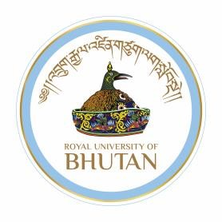
Royal University of Bhutan

རིག་གཞུང་མཐོ་རིམ་སོབ་གྲྭ སྟག་རྩེ།

College of Language and Culture Studies

Taktse

Authorization Letter

I, Mr./Ms.........................................................bearing SID No......................................................
Course…………….……Year of Pass out…………………Contact No................................…
Hereby authorize Mr./Ms.................................................... bearing CID No................................. working as......................................................(Designation) at.....................................to collect my ☐original degree certificate ☐academic transcripts ☐others ..................................(specify for any other documents) from the exam cell (College of Language and Culture Studies).

I hereby affirm that I will take full responsibility and be accountable in case of loss/damage of my ☐original degree certificate ☐academic transcripts ☐others .............................................(specify for any other documents)

Your Signature:

Name of the Receiver:

Dated signature:

Contact No:

+975-17110755/16910612 Post box # 554, www.clcs.edu.bt

